CPE301 – SPRING 2019

Design Assignment DA2c

Student Name: Daniel Senda

Student #: 5002362633

Student Email: sendad1@unlv.nevada.edu

Primary Github address: https://github.com/dsenda/Smiles

Directory: DA2c

Submit the following for all Labs:

1. In the document, for each task submit the modified or included code (only) with highlights and justifications of the modifications. Also, include the comments.
2. Use the previously create a Github repository with a random name (no CPE/301, Lastname, Firstname). Place all labs under the root folder ESD301/DA, sub-folder named LABXX, with one document and one video link file for each lab, place modified asm/c files named as LabXX-TYY.asm/c.
3. If multiple asm/c files or other libraries are used, create a folder LabXX-TYY and place these files inside the folder.
4. The folder should have a) Word document (see template), b) source code file(s) and other include files, c) text file with youtube video links (see template).

1. **COMPONENTS LIST AND CONNECTION BLOCK DIAGRAM w/ PINS**

*List of Components used:*

Atmel Studio 7

ATmega328P Xplained Mini

Arduino Shield.

*Block diagram with pins used in the Atmega328P:*

Pin 2 of Port B was used to light up LED Pin 2 of Port C was used (Switch)

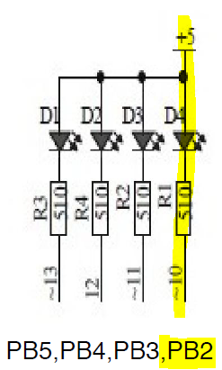 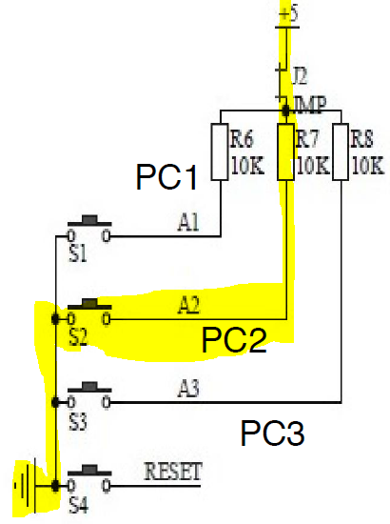

1. **INITIAL/DEVELOPED CODE OF TASK DA2a**

The following is the **first C code** that creates a square waveform with period of 0.725s and 60% duty cycle.

// c_code1_waveform.c

// Daniel Senda

// Square waveform with period of 0.725s and 60% duty cycle.

#define *F_CPU* 16000000

#include <avr/io.h>

#include <util/delay.h>

int num = 1; // Used for while loop.

int main(void)

{

DDRB = 0b100; // Enables PB2 as output.

while(num = 1) // Loop used to create waveform.

{

PORTB = 0xFB; // Sets PB2 to 0.

*_delay_ms*(435); // Turns LED on for 435ms (Ton).

PORTB = PORTB^0b100; // Sets PB2 to 1.

*_delay_ms*(290); // Turns LED off for 290ms (Toff).

}

return 0;

}

Next is the **second C code** that turns on an LED for 1.25 seconds after the pushbutton is pressed.

// c_code2_switched_LEDpulse_1_25s.c

// Daniel Senda

// Turn on LED for 1.25s after pushbutton is pressed.

#define *F_CPU* 16000000

#include <avr/io.h>

#include <util/delay.h>

int num = 1; // Used for while loop.

int comp; // Used to compare in loop.

int main(void)

{

DDRB = 0b100; // Enables PB2 as output.

DDRC = 0x00; // Enables PC2 as input.

while(num = 1) // Loop used to keep program running.

{

comp = PINB & 0b100; // Bit masking.

if (comp = 0b100) // If button is pressed, this will be true.

{

PORTB = 0xFB; // Sets PB2 to 0.

*_delay_ms*(1250); // Turns LED on for 1.25s (Ton).

PORTB = PORTB^0b100;// Turns LED back off.

}

}

return 0;

}

1. **DEVELOPED MODIFIED CODE OF TASK DA2c from TASK DA2a.**
2. The following pair of C codes is part of the **first task** of DA2c.

The **first C code** in this pair is to modify the first C code of DA2a using **Timer 0 and normal mode**.

// 1c_code_1_timer0_norm_mode.c

// Daniel Senda

// Square waveform with period of 0.725s and 60% duty cycle.

#include <avr/io.h>

int O_F = 0; // Used for overflow count.

int main(void)

{

DDRB = 0xff; // Sets port b pins to outputs.

int LED1 = 0b11111011; // Output value used to turn on LED.

TCCR0B = 0x0; // Sets normal mode.

TCCR0B = 0b00000101; // Sets 1024 pre-scaler.

while (1) // While loop that generates wave.

{

PORTB = LED1; // Turns LED connected to PB2 on.

TCNT0 = 0; // Resets timer.

for (O_F = 0; O_F < 1320; O_F++) // For loop used to create delay.

{

while (TCNT0 <= 254){}; // Loop used to keep track of overflows.

}

PORTB = 255; // Turns LED off.

TCNT0 = 0; // Resets timer.

for (O_F = 0; O_F < 1920; O_F++) // For loop used to create delay.

{

while (TCNT0 <= 254){}; // Loop used to keep track of overflows.

}

}

}

The **second C code** in this pair is to modify the second C code of DA2a using **Timer 0 and normal mode**.

// 1c_code_2_timer0_norm_mode.c

// Daniel Senda

// Turn on LED for 1.25s after pushbutton is pressed.

#include <avr/io.h>

int O_F = 0; // Used for overflow count.

int main (void)

{

DDRB = 0xFF; // Set PORTB as output.

DDRC &= (0 << 2); // Set PORTC as input

PORTC |= (1 << 2); // Enable pull-up.

TCCR0B = 0x0; // Sets normal mode.

TCCR0B = 0b00000101; // Sets 1024 pre-scaler.

while (1)

{

if (PINC & 0x04) // If switch is not pressed.

PORTB = 0b11111111; // Turns of LED.

else // If switch is pressed.

{

PORTB = 0b11111011; // Turns LED on.

TCNT0 = 0; // Resets timer.

for (O_F = 0; O_F < 5630; O_F++) // For loop used to create delay.

{

while (TCNT0 <= 254){}; // Loop used to keep track of

overflows.

}

}

}

return 0;

}

1. The following pair of C codes is part of the **second task** of DA2c.

The **first C code** in this pair is to modify the first C code of DA2a using **TIMER0_OVF_vect interrupt mechanism in normal mode**.

// 2c_code_1_timer0_interrupts_norm_mode.c

// Daniel Senda

// Square waveform with period of 0.725s and 60% duty cycle.

#include <avr/io.h>

#include <avr/interrupt.h>

volatile int O_F = 0; // Used for overflow count.

int num = 0; // Used for while loops.

int LED1 = 0b11111011; // Output value used to turn LED on.

void initiate_timer()

{

TCCR0B = 0x0; // Sets normal mode.

TCCR0B = 0b00000101; // Sets 1024 pre-scaler.

TIMSK0 |= (1 << TOIE0); // Enables overflow interrupt.

sei(); // Enables global interrupts.

TCNT0 = 0; // Resets timer.

}

ISR(TIMER0_OVF_vect) // Keeps count of overflows.

{

O_F++; // Increments overflow count.

}

int main(void)

{

DDRB = 0xff; // Sets port b pins to outputs.

initiate_timer(); // Function that initiates timer.

while (1) // While loop that generates wave.

{

PORTB = LED1; // Turns LED connected to PB2 on.

num = 0; // Resets num value.

TCNT0 = 0; // Resets timer.

while(num <= 0) // For loop used to create delay.

{

if (O_F >= 18) // If overflow count equals 18:

{

num++; // Increment num to exit loop.

O_F = 0; // Reset overflow count.

}

}

PORTB = 255; // Turns LED off.

num = 0; // Resets num value.

TCNT0 = 0; // Resets timer.

while(num <= 0) // For loop used to create delay.

{

if (O_F >= 26) // If overflow count equals 26:

{

num++; // Increment num to exit loop.

O_F = 0; // Reset overflow count.

}

}

}

}

The **second C code** in this pair is to modify the second C code of DA2a using **TIMER0_OVF_vect interrupt mechanism in normal mode**.

// 2c_code_2_timer0_interrupts_norm_mode.c

// Daniel Senda

// Turn on LED for 1.25s after pushbutton is pressed.

#include <avr/io.h>

#include <avr/interrupt.h>

volatile int O_F = 0; // Used for overflow count.

int num = 0; // Used for while loops.

int LED1 = 0b11111011; // Output value used to turn LED on.

void initiate_timer()

{

TCCR0B = 0x0; // Sets normal mode.

TCCR0B = 0b00000101; // Sets 1024 pre-scaler.

TIMSK0 |= (1 << TOIE0); // Enables overflow interrupt.

sei(); // Enables global interrupts.

TCNT0 = 0; // Resets timer.

}

ISR(TIMER0_OVF_vect) // Keeps count of overflows.

{

O_F++; // Increments overflow count.

}

int main(void)

{

DDRB = 0xff; // Sets port b pins to outputs.

DDRC &= (0 << 2); // Set PORTC as input

PORTC |= (1 << 2); // Enable pull-up.

initiate_timer(); // Function that initiates timer.

while (1) // While loop that generates wave.

{

if (PINC & 0x04) // If switch is not pressed.

PORTB = 0b11111111; // Turns LED off.

else // If switch is pressed.

{

PORTB = LED1; // Turns LED connected to PB2 on.

num = 0; // Resets num value.

TCNT0 = 0; // Resets timer.

while(num <= 0) // For loop used to create delay.

{

if (O_F >= 76) // If overflow count equals 76:

{

num++; // Increment num to exit loop.

O_F = 0; // Reset overflow count.

}

}

}

}

}

1. The following pair of C codes is part of the **third task** of DA2c.

The **first C code** in this pair is to modify the first C code of DA2a using **TIMER0_COMPA_vect interrupt mechanism in CTC mode**.

// 3c_code_1_timer0_interrupts_ctc_mode.c

// Daniel Senda

// Square waveform with period of 0.725s and 60% duty cycle.

#include <avr/io.h>

#include <avr/interrupt.h>

volatile int O_F = 0; // Used for overflow count.

int num = 0; // Used for while loops.

int LED1 = 0b11111011; // Output value used to turn LED on.

void initiate_timer()

{

TCCR0B = 0b10; // Sets CTC mode.

TCCR0B = 0b00000101; // Sets 1024 pre-scaler.

TIMSK0 |= (1 << OCIE0A); // Enables output compare match interrupt.

OCR0A = 255; // Sets output compare register A to 255.

sei(); // Enables global interrupts.

TCNT0 = 0; // Resets timer.

}

ISR(TIMER0_COMPA_vect) // Keeps count of overflows.

{

O_F++; // Increments overflow count.

}

int main(void)

{

DDRB = 0xff; // Sets port b pins to outputs.

initiate_timer(); // Function that initiates timer.

while (1) // While loop that generates wave.

{

PORTB = LED1; // Turns LED connected to PB2 on.

num = 0; // Resets num value.

TCNT0 = 0; // Resets timer.

while(num <= 0) // For loop used to create delay.

{

if (O_F >= 18) // If overflow count equals 18:

{

num++; // Increment num to exit loop.

O_F = 0; // Reset overflow count.

}

}

PORTB = 255; // Turns LED off.

num = 0; // Resets num value.

TCNT0 = 0; // Resets timer.

while(num <= 0) // For loop used to create delay.

{

if (O_F >= 26) // If overflow count equals 26:

{

num++; // Increment num to exit loop.

O_F = 0; // Reset overflow count.

}

}

}

}

The **second C code** in this pair is to modify the 2nd C code of DA2a using **TIMER0_COMPA_vect interrupt mechanism in CTC mode**.

// 3c_code_2_timer0_interrupts_ctc_mode.c

// Daniel Senda

// Turn on LED for 1.25s after pushbutton is pressed.

#include <avr/io.h>

#include <avr/interrupt.h>

volatile int O_F = 0; // Used for overflow count.

int num = 0; // Used for while loops.

int LED1 = 0b11111011; // Output value used to turn LED on.

void initiate_timer()

{

TCCR0B = 0b10; // Sets CTC mode.

TCCR0B = 0b00000101; // Sets 1024 pre-scaler.

TIMSK0 |= (1 << OCIE0A); // Enables output compare match interrupt.

OCR0A = 255; // Sets output compare register A to 255.

sei(); // Enables global interrupts.

TCNT0 = 0; // Resets timer.

}

ISR(TIMER0_COMPA_vect) // Keeps count of overflows.

{

O_F++; // Increments overflow count.

}

int main(void)

{

DDRB = 0xff; // Sets port b pins to outputs.

DDRC &= (0 << 2); // Set PORTC as input

PORTC |= (1 << 2); // Enable pull-up.

initiate_timer(); // Function that initiates timer.

while (1) // While loop that generates wave.

{

if (PINC & 0x04) // If switch is not pressed.

PORTB = 0b11111111; // Turns LED off.

else // If switch is pressed.

{

PORTB = LED1; // Turns LED connected to PB2 on.

num = 0; // Resets num value.

TCNT0 = 0; // Resets timer.

while(num <= 0) // For loop used to create delay.

{

if (O_F >= 76) // If overflow count equals 76:

{

num++; // Increment num to exit loop.

O_F = 0; // Reset overflow count.

}

}

}

}

}

1. **SCHEMATICS**

For the first C codes in each pair, the following schematic was used. PINB2 would go low to turn on the LED for 435ms and would go high to turn of the LED for 290ms.



For the second C codes in each pair, the same LED schematic was used as shown previously. In addition, the following switch was used, PINC2, with the jumper(J2) in place. When the switch would get pressed, the PC2 would go low and would in result turn on LED D4 for 1.25s. Then it would shut-off and would wait to get pressed again.



1. **SCREENSHOTS OF EACH TASK OUTPUT (ATMEL STUDIO OUTPUT)**

The following is pictures of the waveform that was created by the first C code in each pair. As can be seen, the output is almost exactly a perfect square waveform with period of 0.725s and 60% duty cycle (Means T-on = 435 ms anf T-off = 290ms).

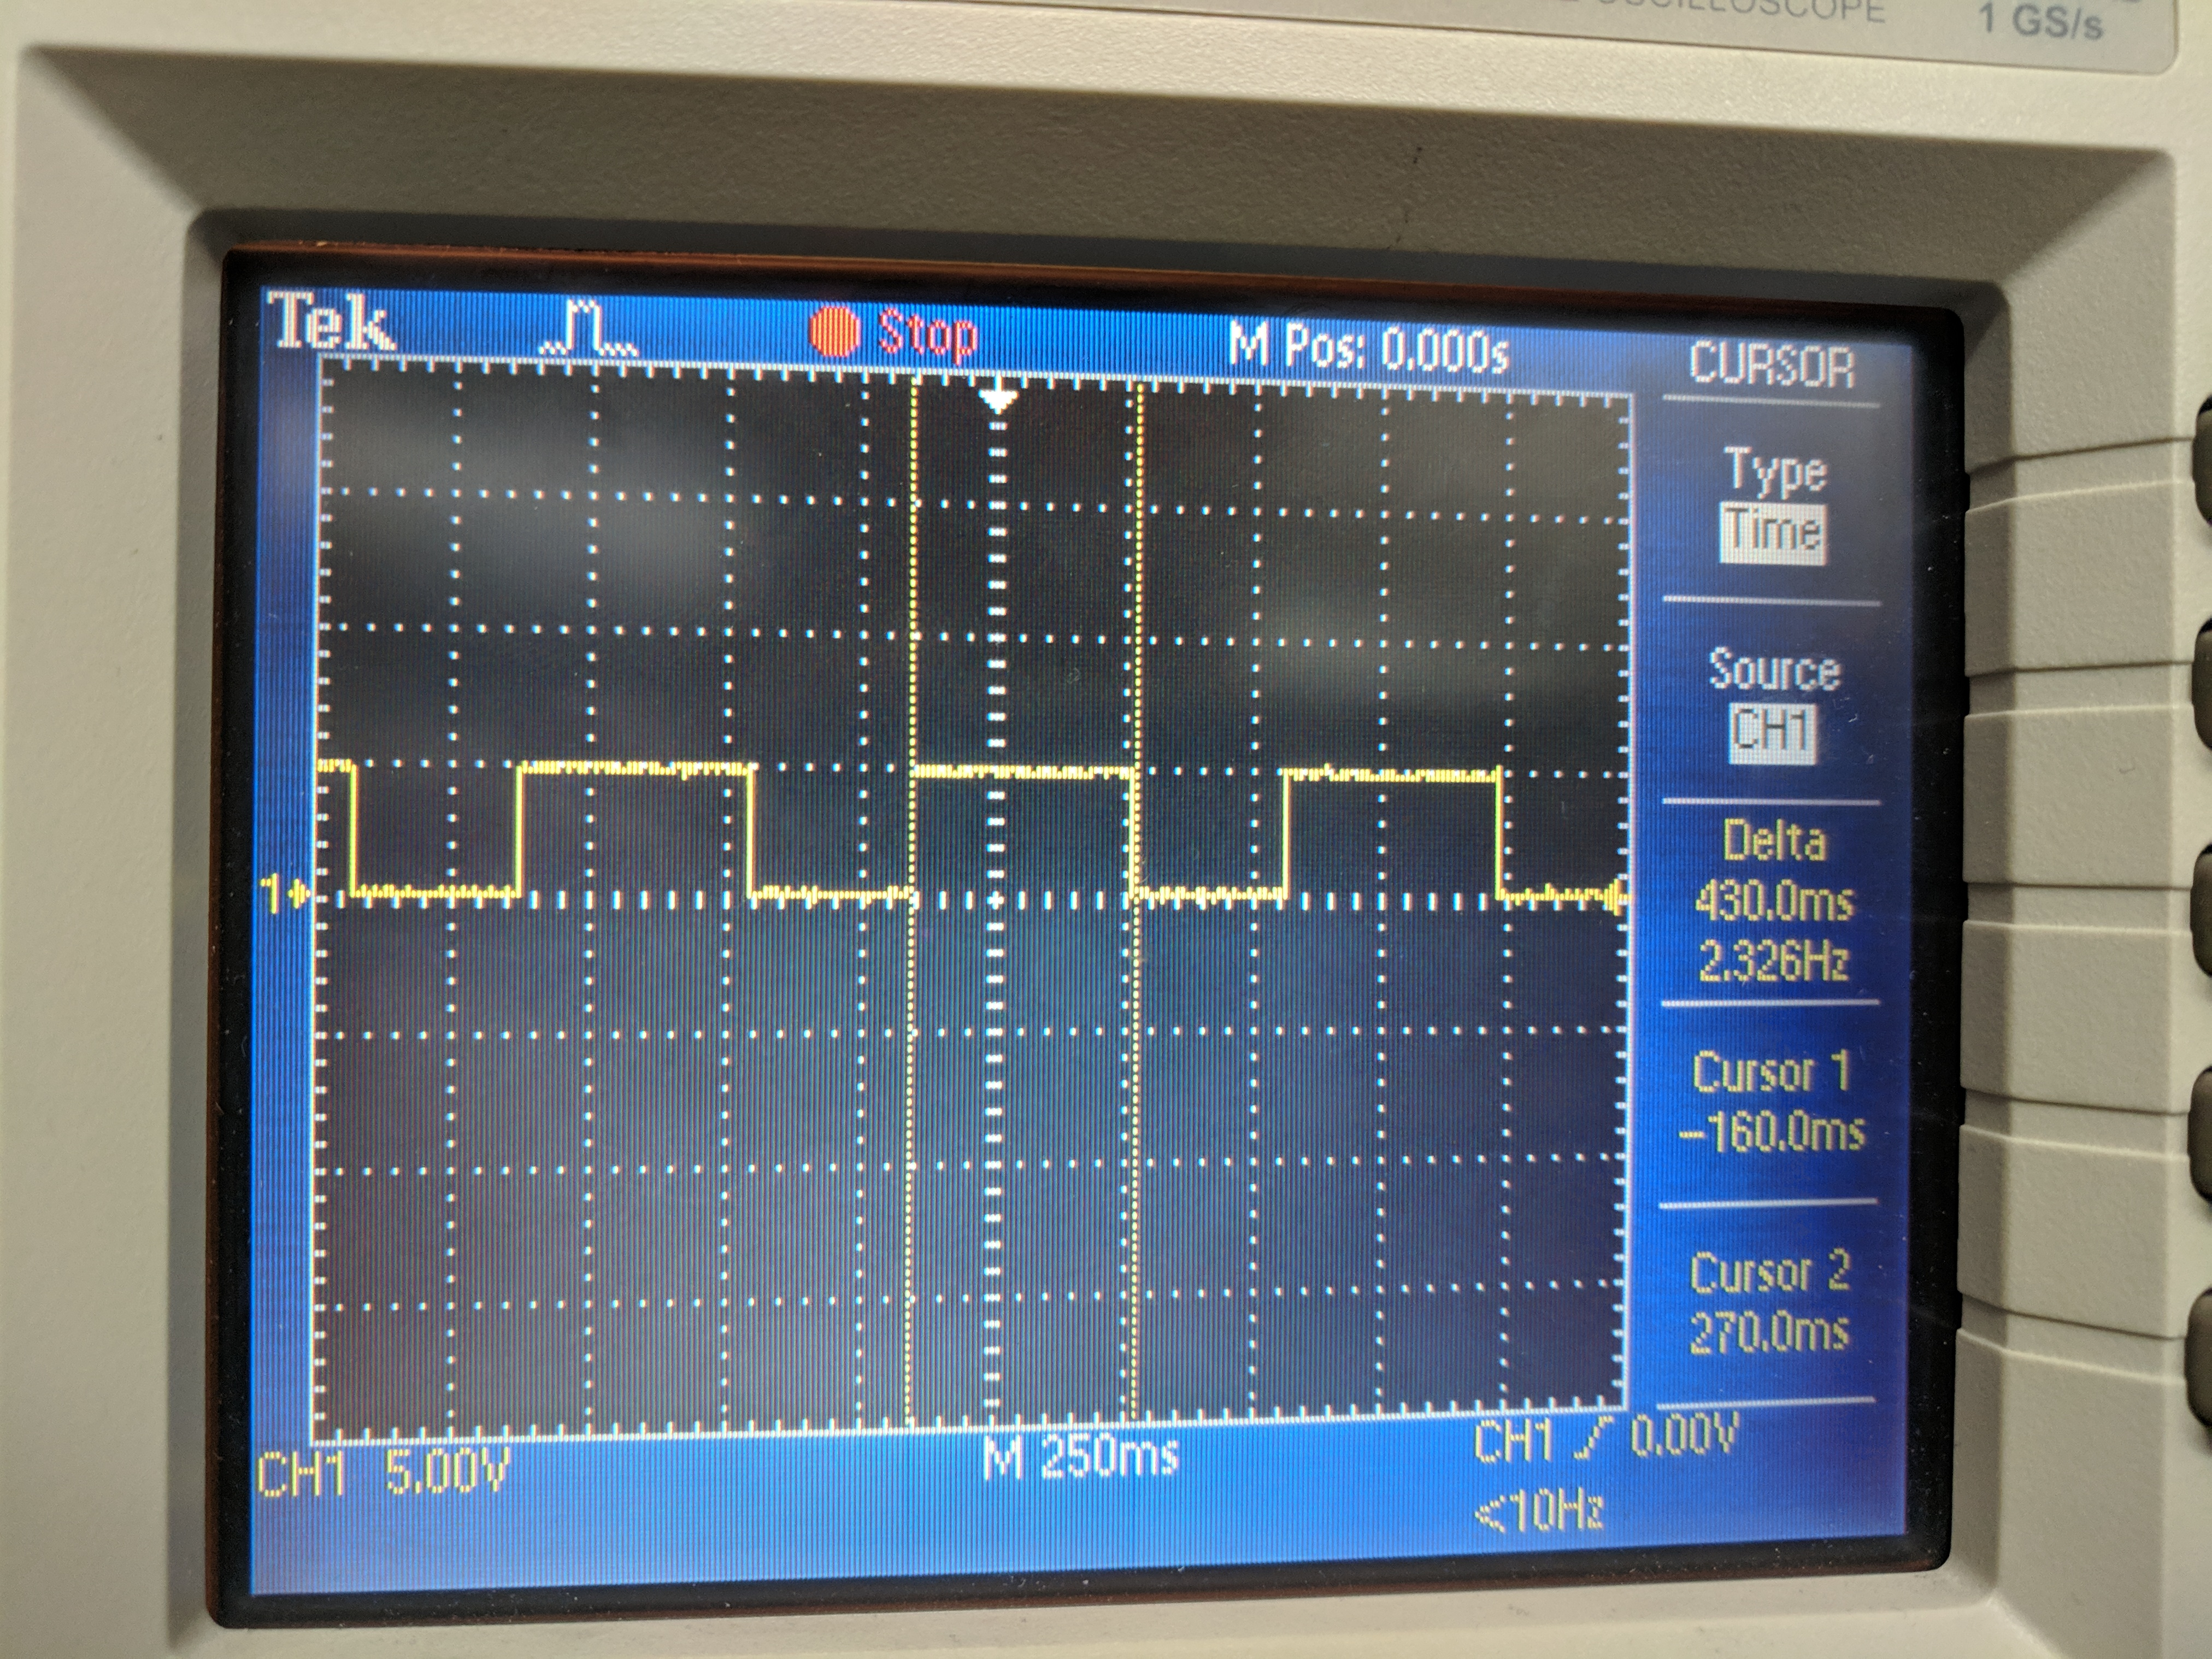 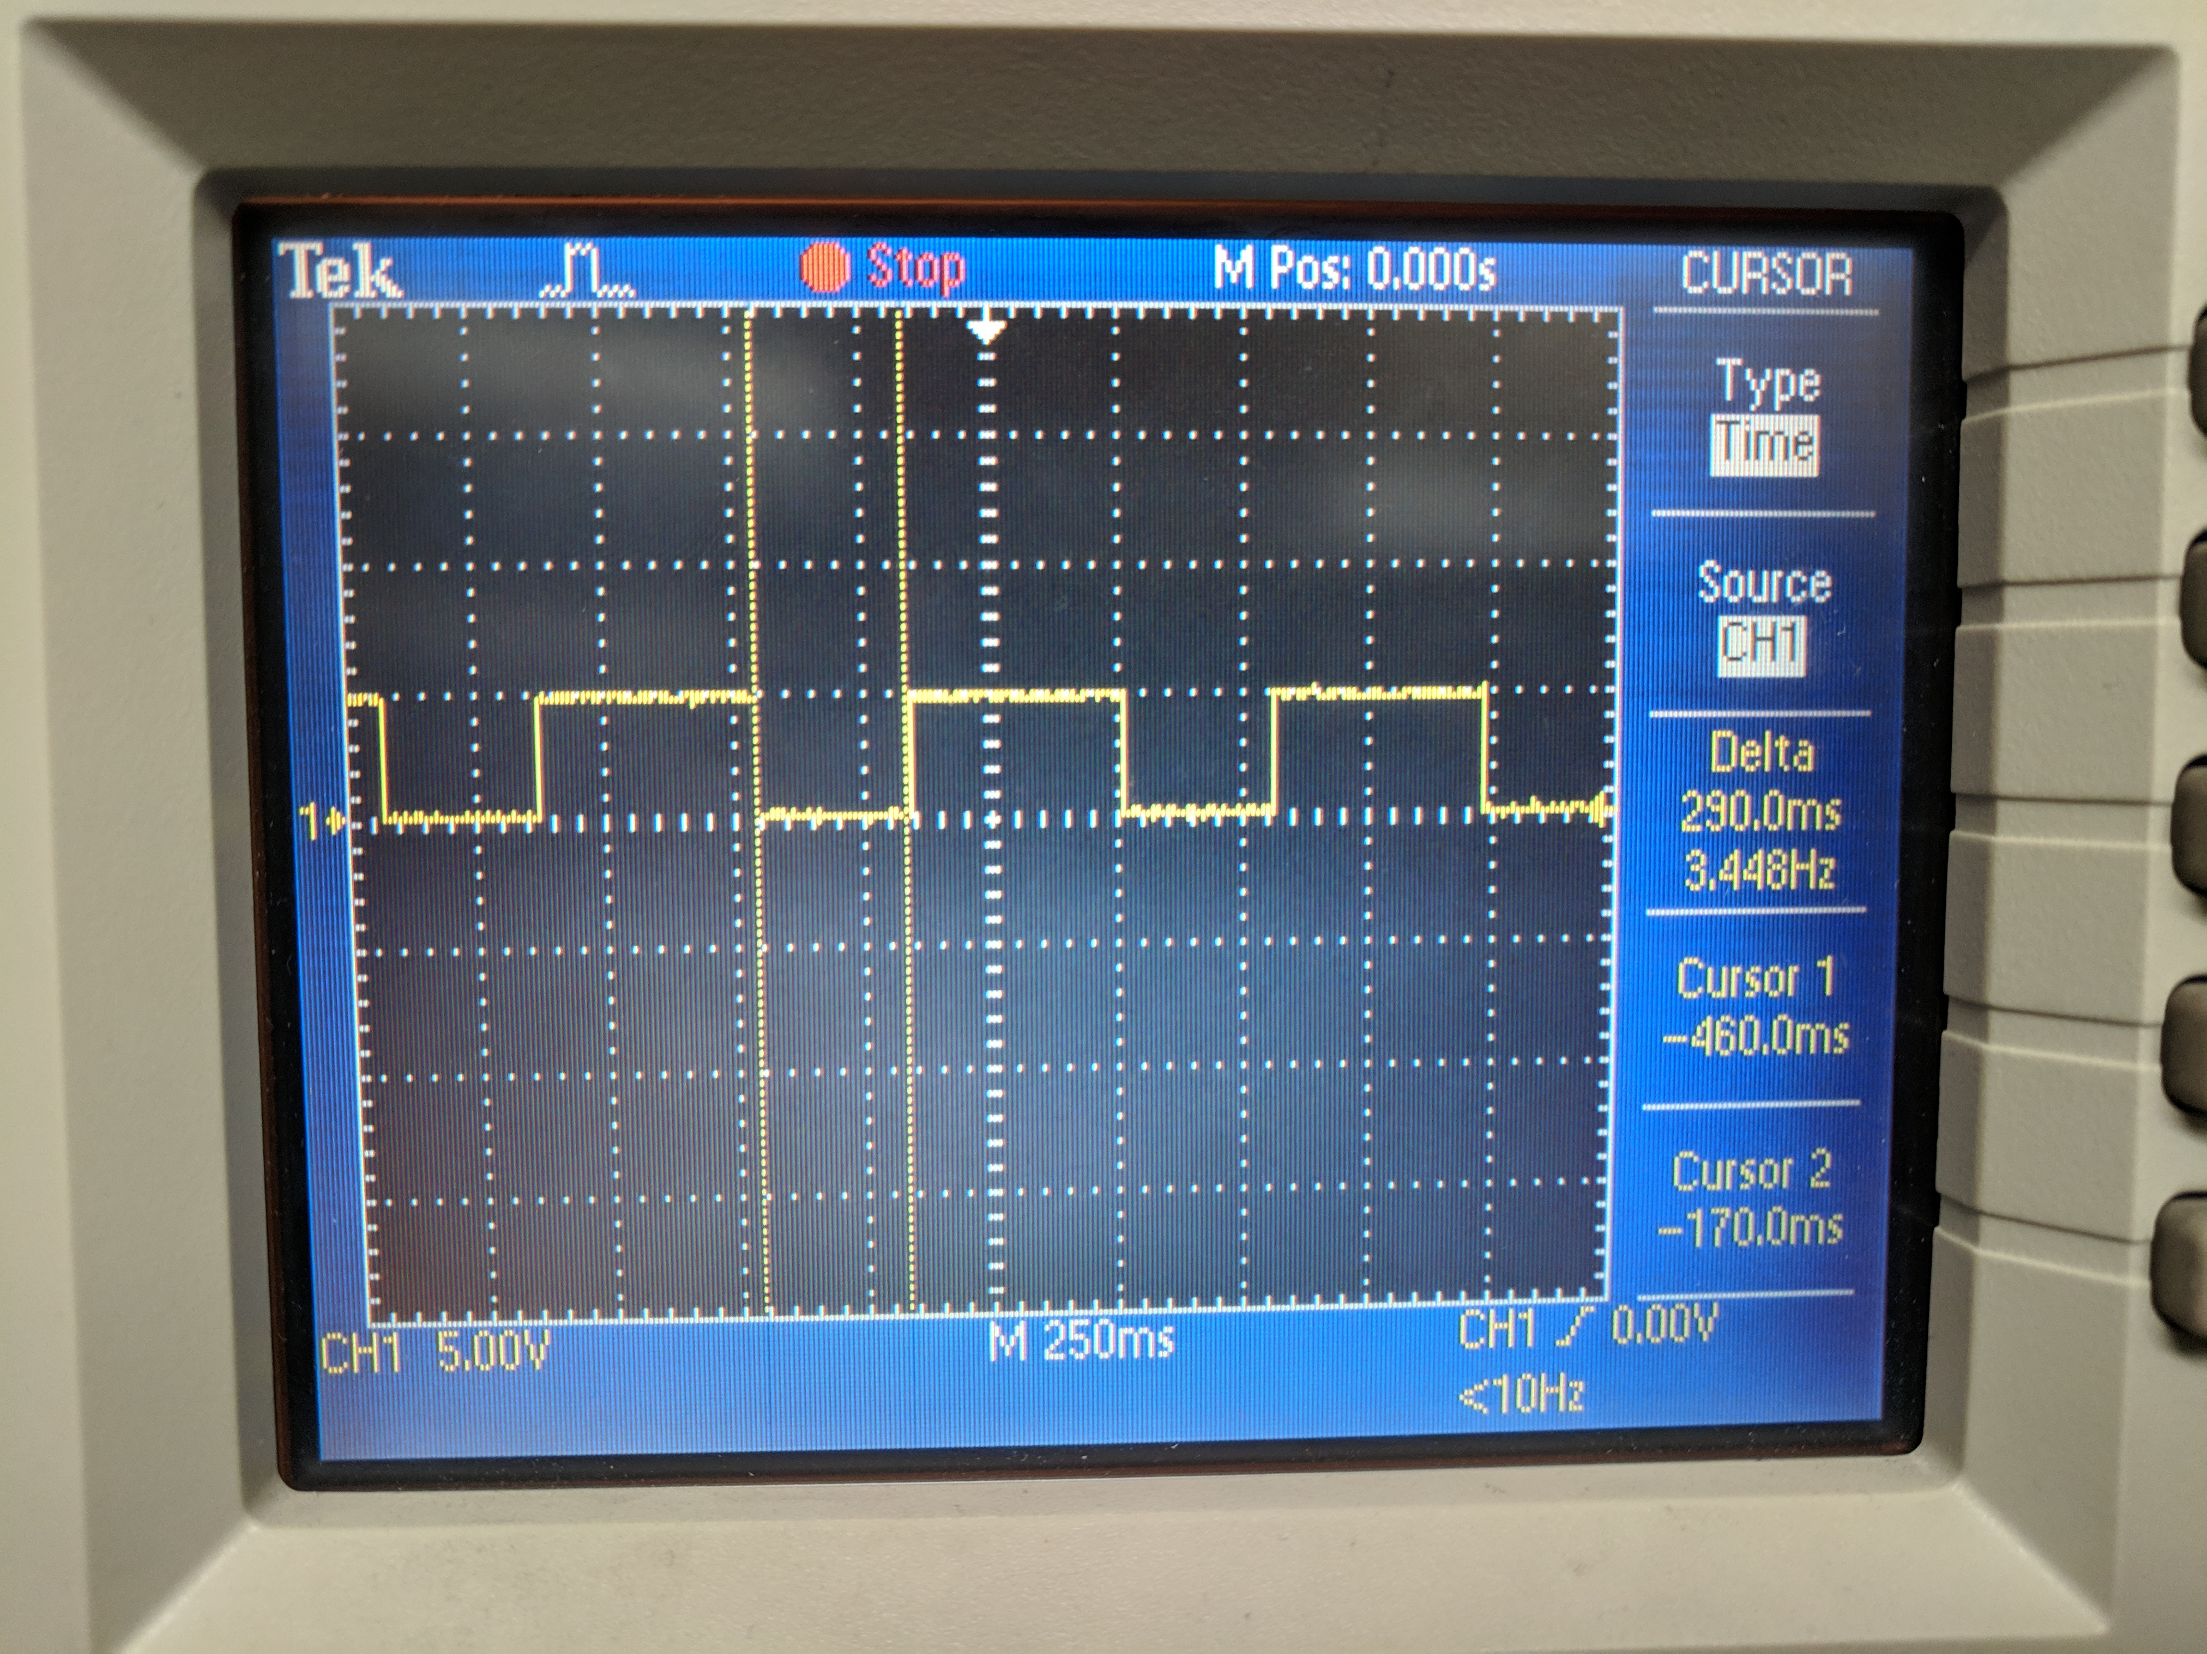

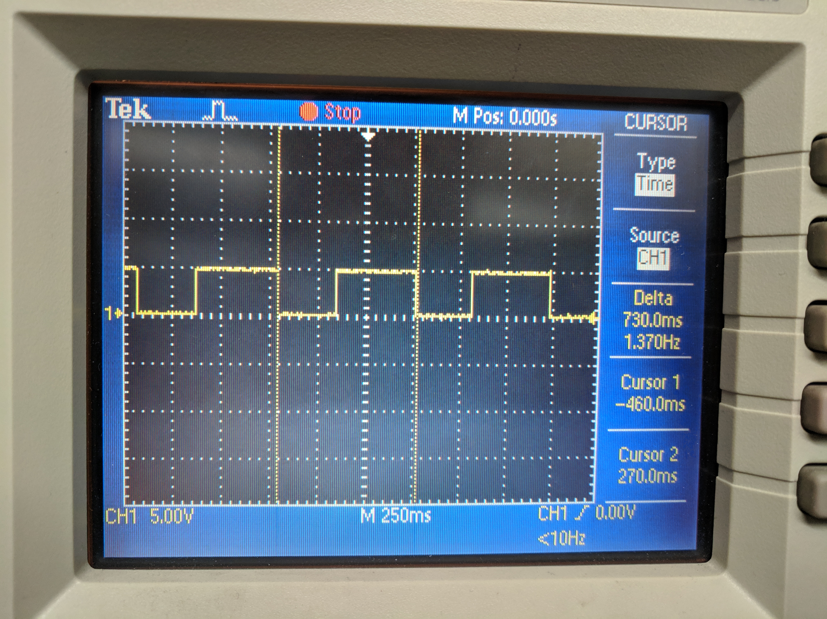

The following is a picture of the waveform that was created by the second C code in each pair. As can be seen, the output goes low for almost exactly 1.25s when the switch is pressed. Since the LED is active low, it turns on for 1.25s, as intended.

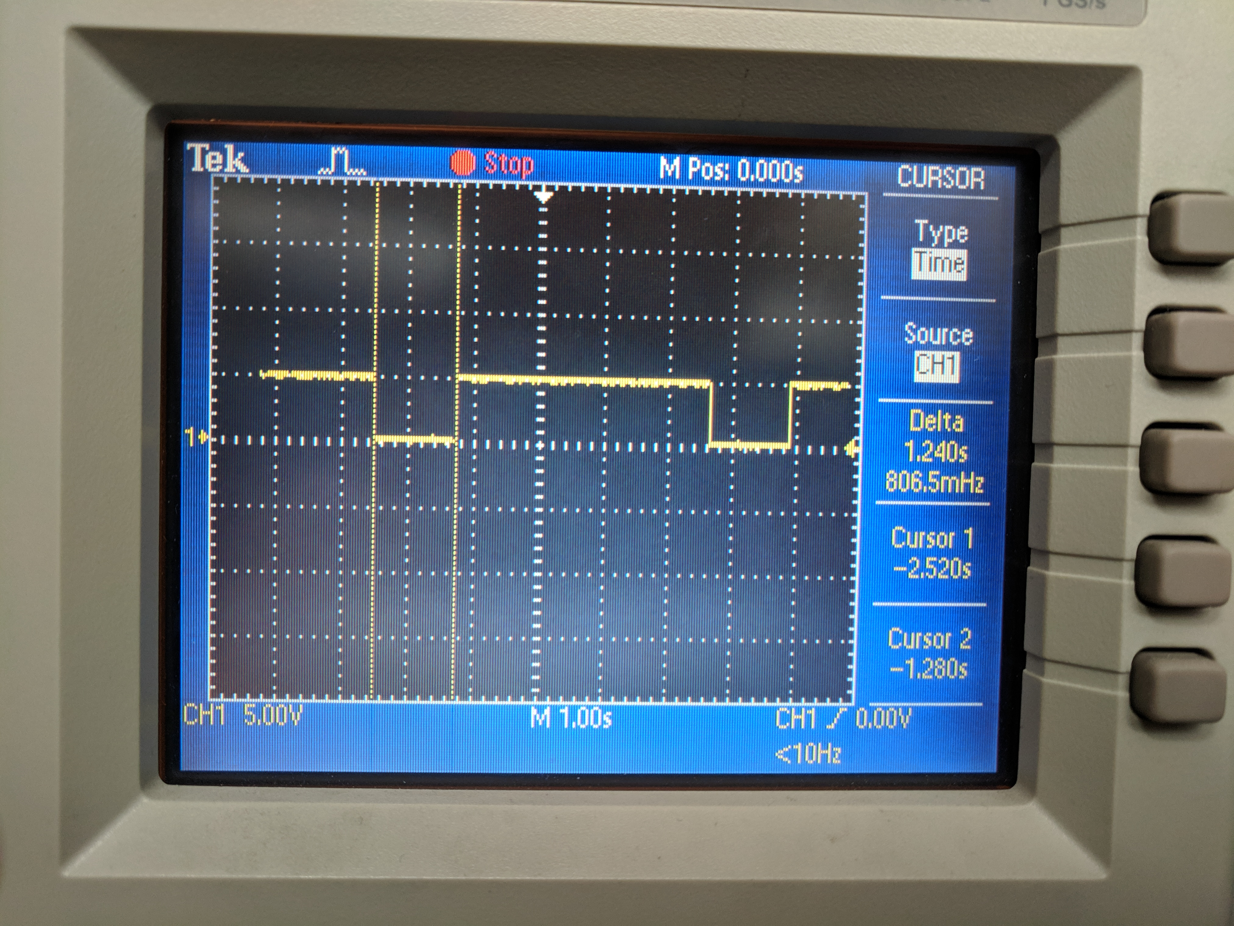

1. **SCREENSHOT OF EACH DEMO (BOARD SETUP)**

The follwowing is a screenshot of the board set-up. The shield sits on top of the xplainned mini.

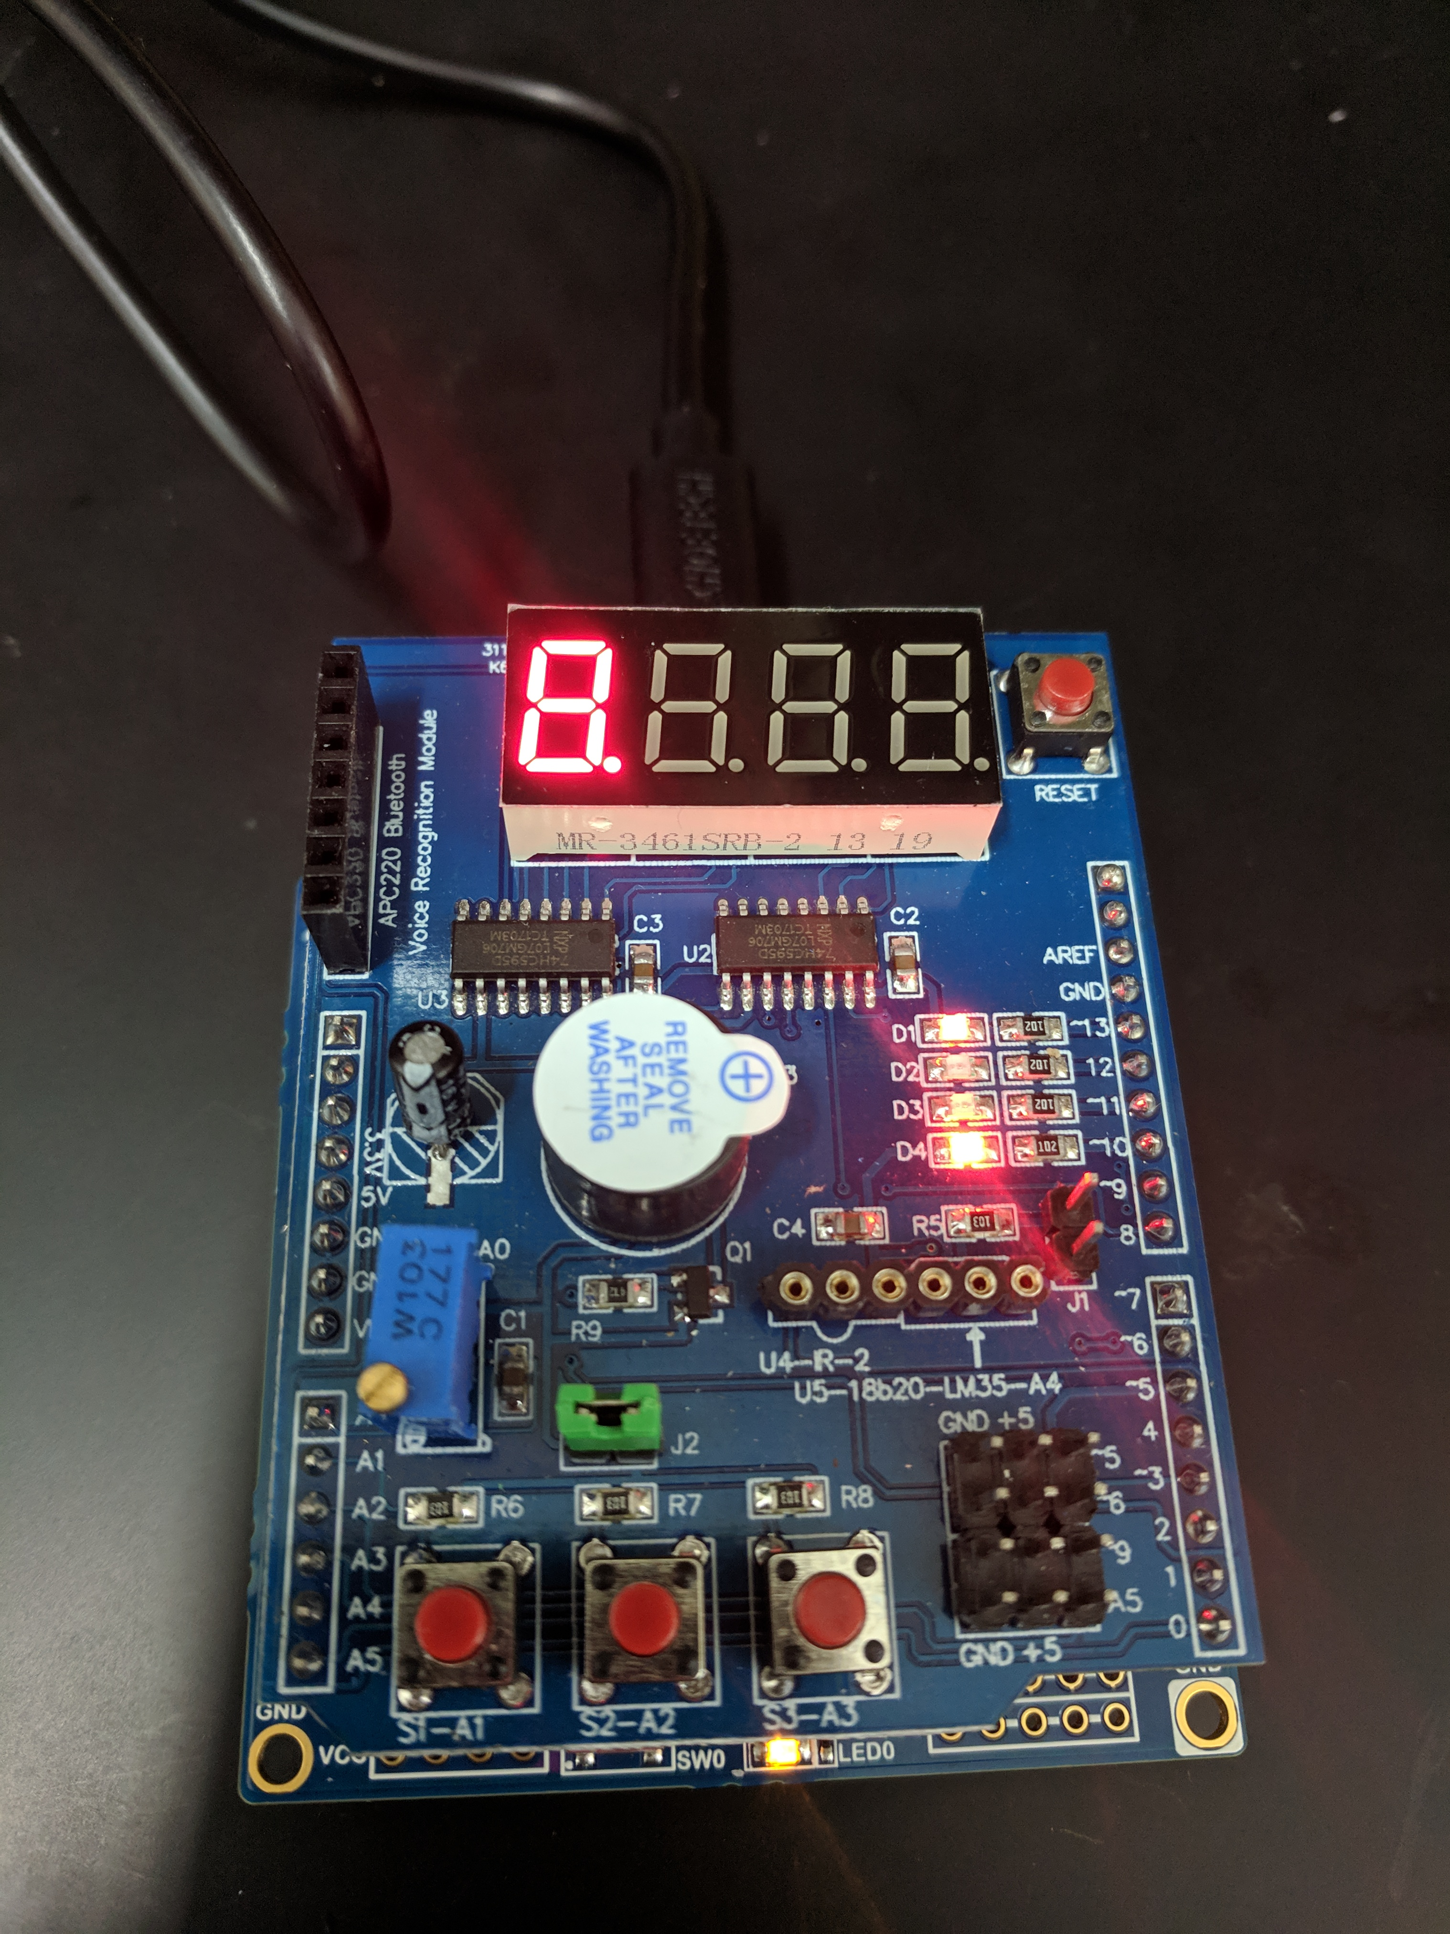

1. **VIDEO LINKS OF EACH DEMO**

<https://youtu.be/5DbOXxpO-n8> (All of demos are in one video)

1. **GITHUB LINK OF THIS DA**

https://github.com/dsenda/Smiles/tree/master/DA2c

**Student Academic Misconduct Policy**

<http://studentconduct.unlv.edu/misconduct/policy.html>

“This assignment submission is my own, original work”.

Daniel Senda